IDEATION PHASE
DEFINE THE PROBLEM STATEMENTS
DATE: | 25/09/2026
TEAM ID: | SWTID-2026-6463
PROJECT NAME: | AI FAQ Assistant API
MAXIMUM MARKS: | 2 Marks

Customer Problem Statement Template:

Create a problem statement to understand your customer's point of view. The Customer Problem Statement template helps you focus on what matters to create experiences people will love.

A well-articulated customer problem statement allows you and your team to find the ideal solution for the challenges your customers face. Throughout the process, you'll also be able to empathize with your customers, which helps you better understand how they perceive your product or service.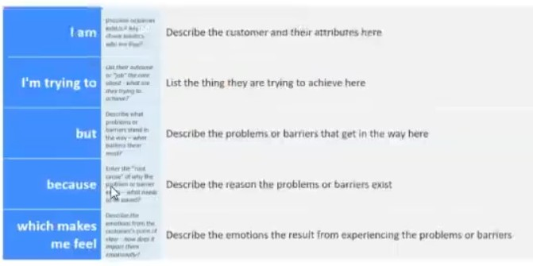

Reference: https://mior.com/templates/customer-problem-statement/
Example:
Problem  Statement | I am  (customer) | I’m trying  to | But | Because | Which makes me feel
Ps-1 | A customer | Find answers to my questions quickly | I cannot find the correct answers easily | FAQs are difficult to search manually | Frustrated and confused
Ps-2 | A support team member | Provide quick answers to customer questions I | spend too much time answering repeated  questions | There is no automated FAQ system | Stressed and overwhelmed

